Date: April 02, 2018

NOTICE

All the students of B.E.First Year, Second Year & Third Year (all branches) are hereby informed that their Second mid semester examination dated April 02 and 03, 2018 has been postponed. The new dates are April 16 and 17, 2018.

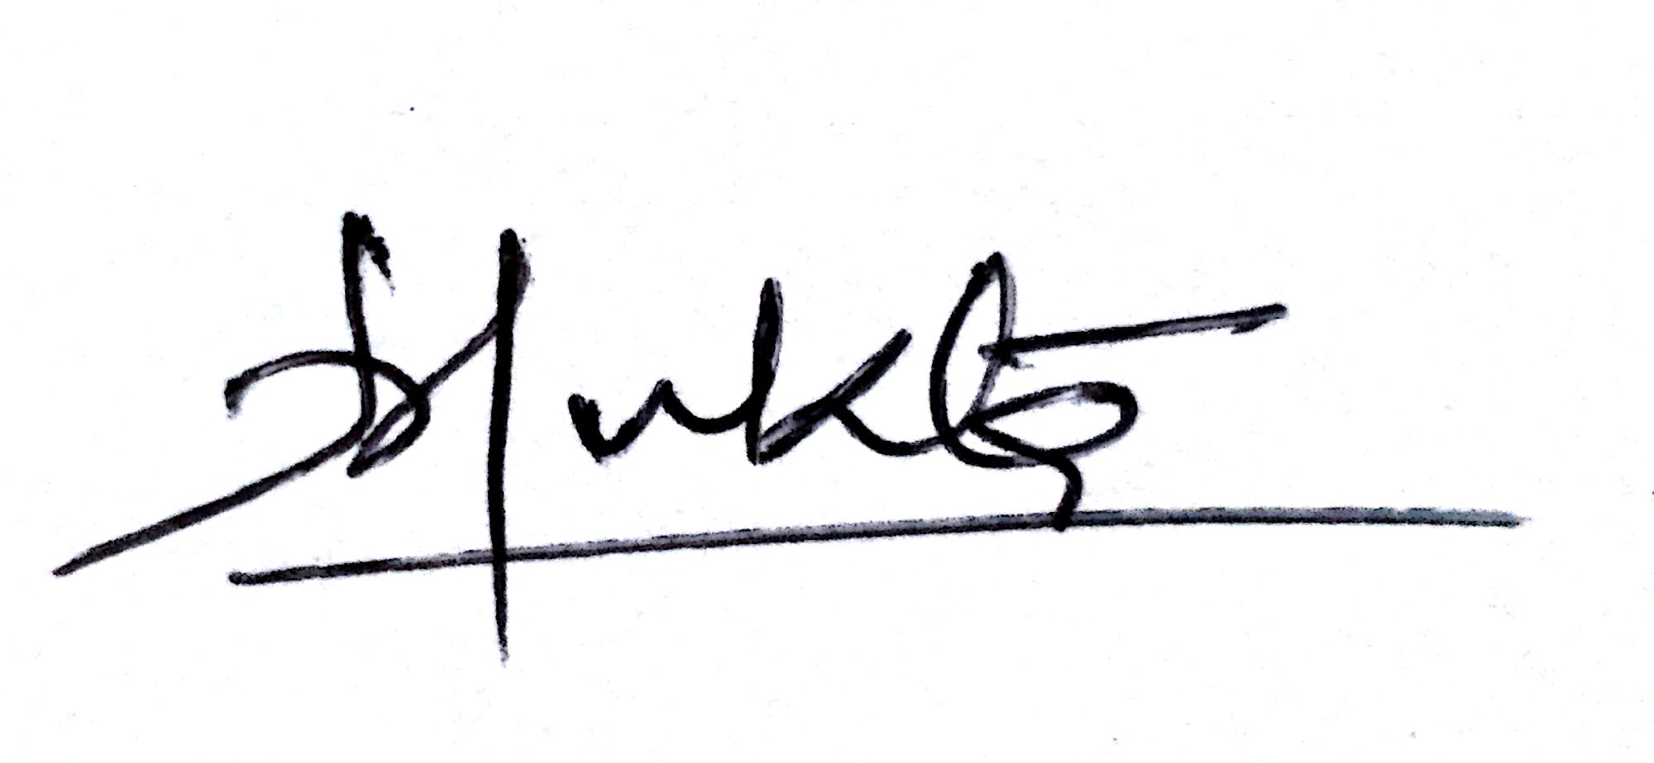

Prof. Mukta Srivastava
Examination Coordinator

Copy to:

- Principal for kind information please (Soft Copy)
- All Head of the Departments (Soft Copy)

